Results Summary for Power BI Project 3
What is the correlation (R2 value) between sales and income?

The correlation between Sales and Income is 0.78.
The scatterplot below presents linear regression between the variables and the corresponding card with correlation value calculated.

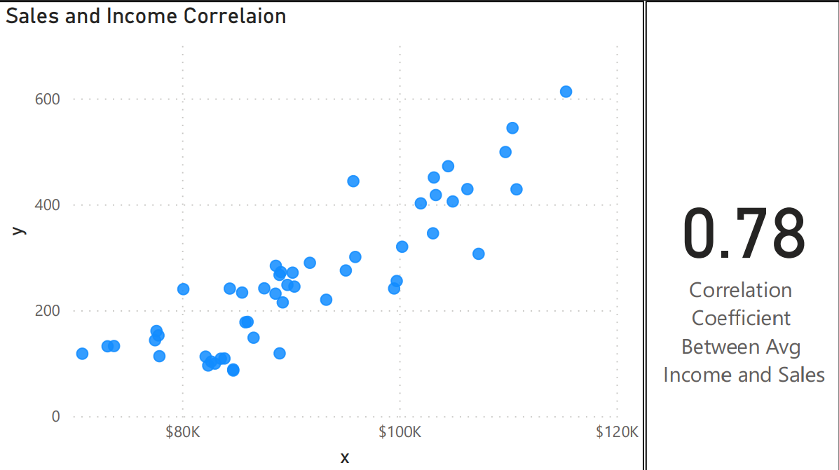

What is the correlation (R2 value) between customer ratings and product return rate?

The correlation between Customer Ratings and product return rate is -0.83, which means that the return rate is less with highest ratings products.
The lineplot below presents linear regression between the variables and the corresponding card with correlation value calculated.

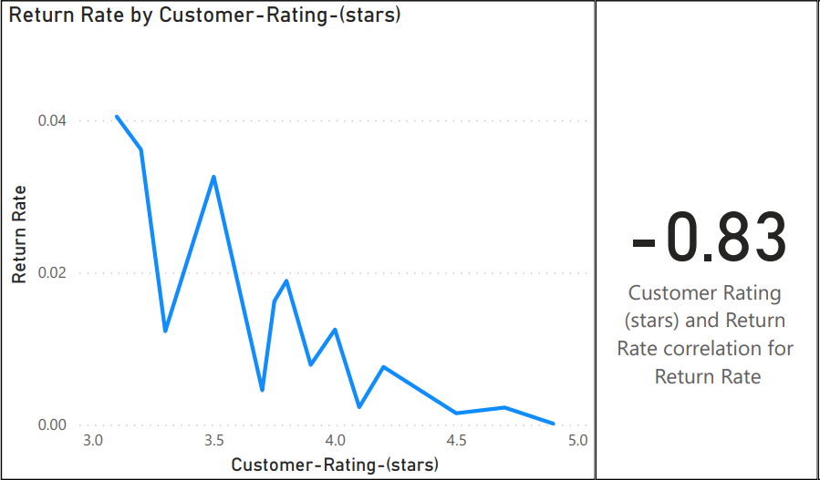

What are the linear regression formulas to predict customer income from customer sales?
The final linear regression formula like the screenshot below:

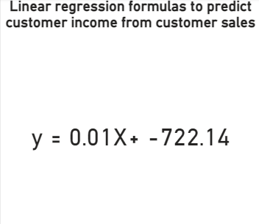

Which customer do you predict has the highest income?

The customer has the full name Jon Little has the highest income by using my prediction model

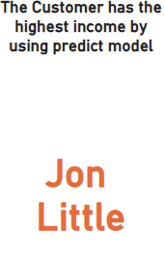

Which product will be advertised the most?

These two cards represent the best and worst performing products with respect to return rate and customer ratings

So from my view, Chronograph Watch will be advertised the most

